Project Planning Phase
Project Planning Template (Product Backlog, Sprint Planning, Stories, Story points)

Date | 09 September 2026
Team ID | SWUID2026190415
Project Name | Medical Diagnosis Center by Service Portal (ServiceNow)
Maximum Marks | 5 Marks

Product Backlog, Sprint Schedule, and Estimation (4 Marks)
Use the below template to create product backlog and sprint schedule
Sprint | Functional Requirement (Epic) | User Story Number | User Story / Task | Story Points | Priority | Team Members
Sprint-1 | Patient Registration | USN-1 | As a patient, I can register using my personal details. | 2 | High | Lahari
Sprint-1 | Patient Registration | USN-2 | As a patient, I receive a registration confirmation email. | 1 | High | Lahari
Sprint-1 | Diagnostic Test Catalog | USN-3 | As a patient, I can view available diagnostic tests. | 3 | High | Lahari
Sprint-1 | Appointment Booking | USN-4 | As a patient, I can book a diagnostic test. | 3 | High | Lahari
Sprint-1 | Appointment Booking | USN-5 | As a patient, I can choose appointment date and time slot. | 2 | High | Lahari
Sprint-2 | Booking Validation | USN-6 | As a receptionist, I can validate available appointment slots. | 3 | High | Lahari
Sprint-2 | Booking Validation | USN-7 | As a receptionist, duplicate appointments are prevented. | 3 | High | Lahari
Sprint-2 | Approval Workflow | USN-8 | As a lab manager, I can approve special diagnostic tests. | 5 | Medium | Lahari
Sprint-2 | Appointment Status | USN-9 | As a patient, I can track appointment status. | 3 | High | Lahari
Sprint-2 | Report Management | USN-10 | As a lab technician, I can upload diagnostic reports. | 3 | High | Lahari
Sprint-2 | Report Management | USN-11 | As a patient, I can download completed reports. | 2 | High | Lahari
Sprint-3 | Payment Management | USN-12 | As a patient, I can pay for diagnostic tests online. | 3 | Medium | Lahari
Sprint-3 | Payment Management | USN-13 | As a patient, payment status is updated automatically. | 3 | Medium | Lahari
Sprint-3 | Email Notifications | USN-14 | As a patient, I receive booking and report notification emails | 2 | High | Lahari
Sprint-3 | Admin Dashboard | USN-15 | As an administrator, I can monitor appointments, reports, and payments. | 5 | High | Lahari
Sprint-3 | Role-Based Access Control | USN-16 | As an administrator, I can manage users and roles. | 3 | High | Lahari

Project Tracker, Velocity & Burndown Chart: (4 Marks)
Sprint | Total Story Points | Duration | Sprint Start Date | Sprint End Date (Planned) | Story Points Completed (as on Planned End Date) | Sprint Release Date (Actual)
Sprint-1 | 14 | 6 Days | 01 Sept 2026 | 06 Sept 2026 | 14 | 06 Sept 2026
Sprint-2 | 16 | 6 Days | 08 Sept 2026 | 13 Sept 2026 | 16 | 13 Sept 2026
Sprint-3 | 16 | 6 Days | 15 Sept 2026 | 20 Sept 2026 | 16 | 20 Sept 2026

Velocity:
Imagine we have a 10-day sprint duration, and the velocity of the team is 20 (points per sprint). Let’s calculate the team’s average velocity (AV) per iteration unit (story points per day)

Total Story Points = 46
Number of Sprints = 3
Velocity=346​=15.33
Average Velocity = 15 Story Points per Sprint
Average Story Points Per Day
Sprint duration = 6 Days
615​=2.5
Average Velocity Per Day = 2.5 Story Points

Burndown Chart:
A burn down chart is a graphical representation of work left to do versus time. It is often used in agile software development methodologies such as Scrum. However, burn down charts can be applied to any project containing measurable progress over time.

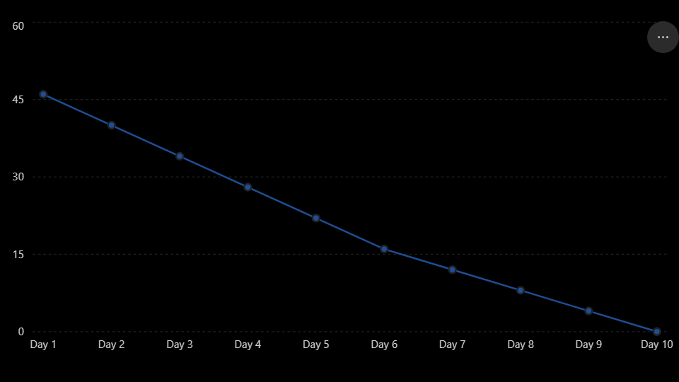

https://www.visual-paradigm.com/scrum/scrum-burndown-chart/
https://www.atlassian.com/agile/tutorials/burndown-charts

Reference:
https://www.atlassian.com/agile/project-management
https://www.atlassian.com/agile/tutorials/how-to-do-scrum-with-jira-software
https://www.atlassian.com/agile/tutorials/epics
https://www.atlassian.com/agile/tutorials/sprints
https://www.atlassian.com/agile/project-management/estimation
https://www.atlassian.com/agile/tutorials/burndown-charts

